**PayDollar/PesoPay/SiamPay PayGate**

**Integration Guide for PestaShop 1.7.x.x**

**Outline**

• **Install the module on PrestaShop**

• **Module configuration**

• **Setup datafeed URL on PayDollar/PesoPay/SiamPay**

Note: This guide assumes that PrestaShop is already installed on your web server.

**Install the module on PrestaShop**

* After logging in to the administrator dashboard, go to Modules > Modules & Services

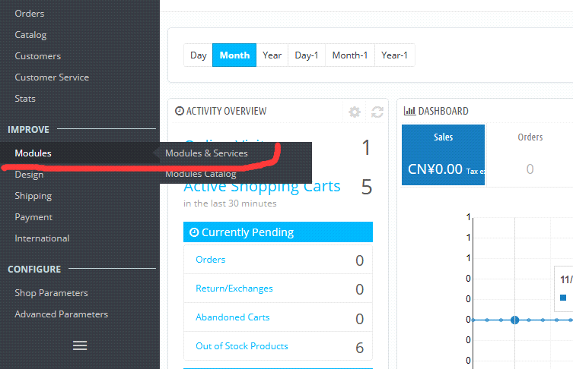

* Click the “UPLOAD A MODULES” and select file for the mudule in zip file format

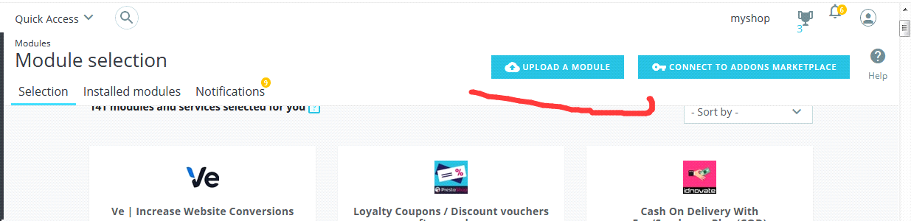

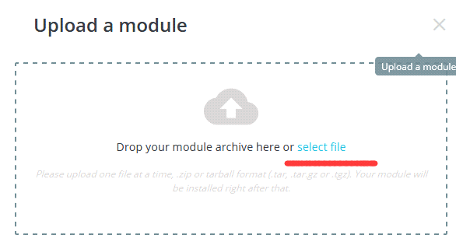

* And then ,if install successed , there will appear the message, liken below

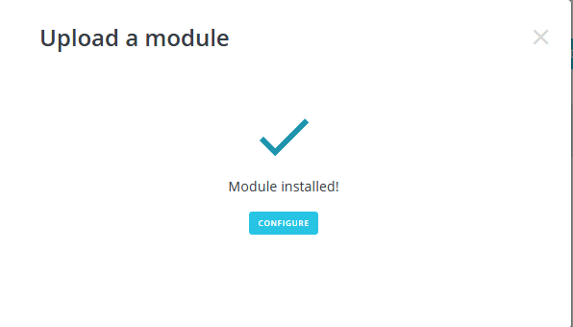

**Module Configuration**

* First, go to Modules > Modules & Services and click the “Installed modules ” like below

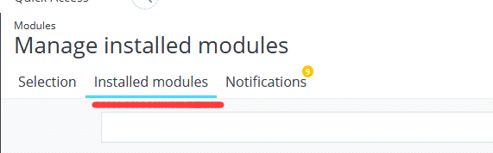

* . Go to the module configuration page by clicking the “Configure” link.

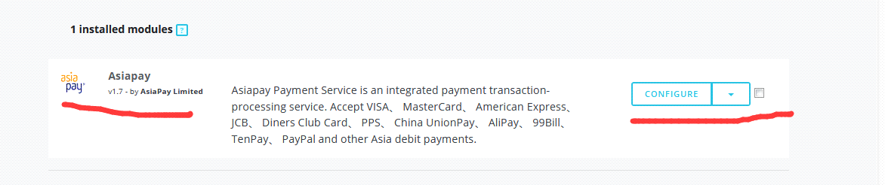

Fill-up the module setting

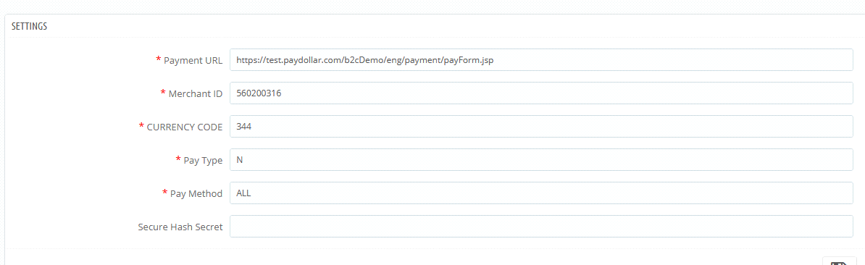

**Payment URL:** The integration URL to which platform you are to integrate.

**Merchant ID:** The merchant account id provided by PayDollar/PesoPay/SiamPay

**Currency:** “Numeric ISO code”

“344” – HKD

“840” – USD

“702” – SGD

“156” – CNY (RMB)

“392” – JPY

“901” – TWD

“036” – AUD

“978” – EUR

“826” – GBP

“124” – CAD

“446” – MOP

“608” – PHP

“764” – THB

“458” – MYR

“360” – IDR

“410” – KRW

“682” – SAR

“554” – NZD

“784” – AED

“096” – BND

**Pay Type:** If you prefer **N** (Sale) or **H** (Authorize) – Depends on the merchant account

**Pay Method:** The payment method to display on the payment page. - Depends on the merchant account

“ALL” – All the available payment method

“CC” – Credit Card Payment

“VISA” – Visa Payment

“Master” – MasterCard Payment

“JCB” – JCB Payment

“AMEX” – AMEX Payment

“Diners” – Diners Club Payment

“PPS” – PayDollar PPS Payment

“PAYPAL” – PayPal By PayDollar Payment

“CHINAPAY” – China UnionPay By PayDollar Payment

“ALIPAY” – ALIPAY By PayDollar Payment

“TENPAY” – TENPAY BY PayDollar Payment

“99BILL” – 99BILL BY PayDollar Payment

“MEPS” – MEPS BY PayDollar Payment

“SCB” –SCB (SCB Easy) BY PayDollar Payment

“BPM” –Bill Payment BY PayDollar Payment

“KTB” –Krung thai Bank (KTB Online) BY PayDollar Payment

“UOB” –United Oversea bank BY PayDollar Payment

“KRUNGSRIONLINE” –Bank of Ayudhya (KRUNGSRIONLINE) BY PayDollar Payment

“TMB” –TMB Bank BY PayDollar Payment

“IBANKING” –Bangkok Bank iBanking BY PayDollar Payment

“UPOP” – UPOP BY PayDollar Payment

**Secure Hash Secret:** Optional. The secret key for the secure hash functionality – Please check with PayDollar/PesoPay/SiamPay.

**Transaction Type:** Optional. Suitable transaction type. Goods/ Service Purchase is the Default value if transaction type not provided.

“01” – Goods/ Service Purchase * Default value if threeDSTransType not provided.

“03” – Check Acceptance

“10” – Account Funding

“11” – Quasi-Cash Transaction

“28” – Prepaid Activation and Load

**Challenge Preference:** Optional. Indicates whether a challenge is requested for the transactions in 3DS2.0. * If “No challenge requested” options are selected, the chargeback liability shift to merchant.

“01” – No preference * Default value if threeDSChallengePreference not provided.

“02” – No challenge requested *

“03” – Challenge requested (Merchant preference)

“04” – Challenge requested (Mandate)

“05” – No challenge requested (transactional risk analysis is already performed) *

“06” – No challenge requested (Data share only)*

“07” – No challenge requested (strong consumer authentication is already performed) *

“08” – No challenge requested (utilise whitelist exemption if no challenge required) *

“09” – Challenge requested (whitelist prompt requested if challenge required)

**Setup the Datafeed URL on PayDollar/PesoPay/SiamPay**

1. Login to your PayDollar

* PayDollar
* Live: <https://www.paydollar.com/b2c2/eng/merchant/index.jsp>
* Test: <https://test.paydollar.com/b2cDemo/eng/merchant/index.jsp>

2. After login, Go to left sidebar on Profile > Profile Settings > Payment Options.

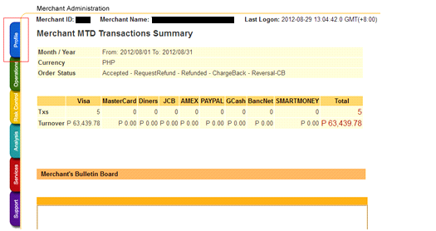

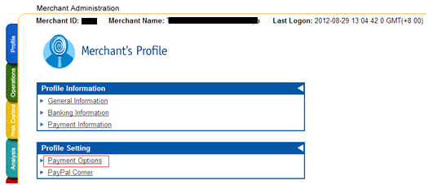

3. Click the “Enable” radio and set the datafeed URL on “Return Value Link” and click the “Update” button.

The datafeed URL should be like this:

<http://www.yourdomain.com/modules/asiapay/datafeed.php>

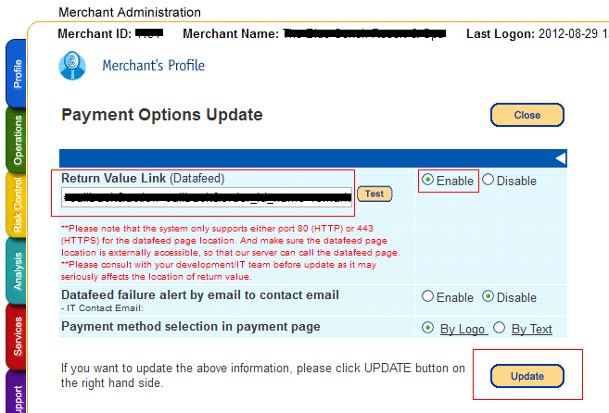

4. On the confirmation page, review your changes then click the “Confirm button”.

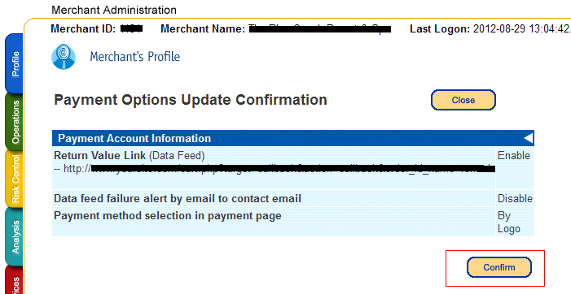

5. The datafeed URL has been set.

